Adult Education Programs 2018-2019

ENTRY-POINT JUDAISM
with Rabbi Gilah Langner
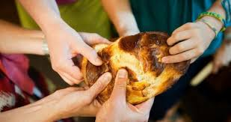
A Three-Part Series in Fall 2018
Board Room, Unitarian Universalist Church of Arlington (UUCA),
4444 Arlington Blvd., Arlington VA
Join Rabbi Gilah and Kol Ami: Northern Virginia Reconstructionist Community for a three-part series this fall on the basic elements of Judaism. No prior knowledge required; each class can be taken individually. Open to everyone. Sunday afternoons from 5 to 6:30 p.m. Free.
Oct. 14: Believing: Jewish beliefs, theology, basic teachings and values
Nov. 4: Behaving: Jewish laws, customs, and rituals
Dec. 16: Belonging: Jewish community, history, and the land of Israel
_____________________________________________________________________________________
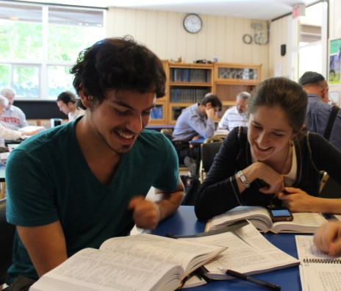
VIRTUAL BEIT MIDRASH
with Rabbi Gilah Langner and Kol Ami Coaches
This year-long "Study Hall" is intended to help boost familiarity and comfort with Jewish worship services. Rabbi Gilah will offer monthly online teaching on individual prayers and the structure of the service; participants will spend a half hour online one-on-one with a coach in each of the next three weeks of the month. Kick-off meeting to be held at UUCA, Sept. 30, 3:30-5:00 p.m. No prior background in prayers or Hebrew needed. Participants can join for a month at a time. Free.
_____________________________________________________________________________
KINGDOM OF OLIVES AND ASH: MONTHLY DISCUSSION GROUP
with Allan Kellum, Herb Levy, and members of UUCA and Kol Ami
We'll read and discuss this book of essays edited by Michael Chabon, offering a glimpse into the human cost of fifty years of Israeli occupation of the West Bank and Gaza. First meeting: September 30, then every last Sunday of the month starting at 7 pm in the Chapel at the UUCA.
For more information, please contact: www.kolamivirginia.org, Tel: 571-271-8387

