SHABBAT MORNING KIDDUSH
Part 1
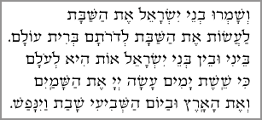
Ve-shameru venei Yisrael et ha-Shabbat, la'asot et ha-Shabbat le-doro'tam berit olam.
Beini u-vein b'nei Yisra-el ot hee le-olam,
Ki sheishet yamim asa Adonai et ha-shamayim ve-et ha-aretz
Uva-yom ha-shevi'i shavat va-yinafash.

The children of Israel should keep Shabbat, observing Shabbat throughout their generations, as an everlasting covenant. It is a sign between Me and the children of Israel forever, that in six days God made the heavens and the earth, and that on the seventh day He was finished and He rested.

Part 2
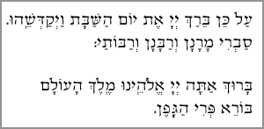
Al kein beirach Adonai et yom ha-Shabbat va-yekad-sheihu.
(Savri? -- everyone responds, L'chaim!)
Baruch ata Adonai, Eloheinu melech ha-olam, borei peri ha gafen. (Others: “Amen”)

Therefore God blessed Shabbat and made it holy.
(What do you say? Everyone: To Life!)
Blessed are you God, King of the Universe, Creator of the fruit of the vine. (Others: “Amen”)

